Little Hands Nursery School Linton & Bartlow
Autumn 1 2023

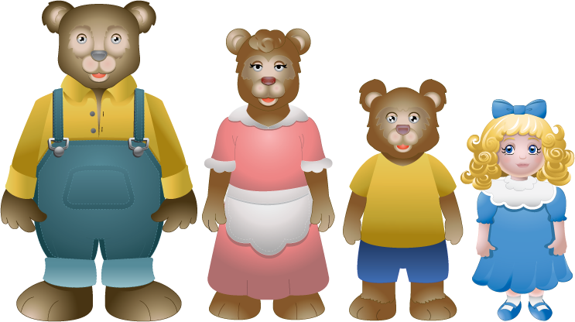

Welcome back to the new academic year and we hope that you have had a fun filled and happy summer break.. Welcome too to all our new children and their families are they start their journey with us.

Staffing
We welcome Alexis Kemp -Reynolds to the team. Lee has moved on from Little Hands, we wish him well for the future. We are still recruiting so we will keep you updated with progress. We will still be seeing Linda (who retired last year!) come in as she covers when needed.

Staff and Key workers
As children and staff change sessions for a new academic year then we review our key worker list. Most children are keeping the key workers they had last year. Any changes we will inform you. We will also organise a parent evening in the next few weeks (via zoom) so that you have chance to talk to your child’s keyworker. Please remember you can make an appointment to see your child’s keyworker should you need to at any time.

Theme
Our theme for the start of this half term will be traditional stories – except week 1 where the children are settling back in/joining us.
Week 2: 3 Billy Goats Gruff
Week 3: Goldilocks and the 3 Bears
Week 4: Little Red Riding Hood
Week 5 The Magic Porridge Pot
Week 6: The Enormous Turnip
Week 7: The 3 Little Pigs

Some activities on offer (but not all) will be, read/react the stories, carry out craft activities, discuss any morals/feelings e.g. should Goldilocks of gone in the house, sharing the porridge, being scared (wolf), discussing what makes us scared and who we can go to – linking into our Staying Safe Theme. We will look at counting, size, shape and quantities throughout the stories.

Our staying safe theme we will be discussing who we can go to for help – within the nursery setting and at home.

Under twos – will be looking at Under the sea, some of the activities on offer will include, craft activities, malleable play, musical instruments

Your child may bring items in for the topic to show us. Can we ask that any other toys brought in, other than comforters are shown to staff and friends and then taken home with you or put in your child’s bag if small enough. Other children always want to play with them, and we cannot guarantee their safety or loss.

Contact Details
If any of the details about your child has changed, particularly telephone contact numbers and address since you filled in our admission form please let Mandy know.

Invoices:
The invoice period has now passed. Any late payments will now be charged a £20.00 late fee penalty (unless an arrangement/discussion has taken place).
Please can we remind you that when using the Childcare Tax Free credits release of the payment needs to be made a minimum of 3 working days before payment is due to allow the funds to come to the nursery account. If you are using this payment we will need the code given to you the first time you use this method of payment. My business manager uses the reference to accredit to the fees.

30 hours funding:
Please can I remind parents/carers that have qualified for the funding that you need to do an eligibility check every 3 months with HMRC. HMRC should remind you. If you are due for 30hrs funding in January 2020 please could you start the process in October. I will need the codes asap for funding claims.

Lunch Boxes/Spare clothes
Please remember to clearly label lunch boxes on the outside and drink bottles with your child’s name. Could all over 2’s bring in water bottles daily. We also ask that all children have spare clothes (even if they may never need them). We are very short on under wear and on the odd occasion some children are reluctant to put on our spare clothes, hence we would need to call you to bring their own in.

Parent/Carer Feedback
We are always keen to have comments and suggestions from you that may improve the quality of care and education we provide for your children. If you wish to remain anonymous then please put your comment or suggestion in an envelope and put in our post box at the entrance gate.

Notes from Parent/Carer in Bag
We do not normally look in children’s bags. If you send information or replies in then please hand them to a member of staff or, if another adult is bringing your child in then ask them to give any notes, etc to staff.

Children away from nursery
Please could we remind you that if your child is absent from nursery for any reason that you please inform us by 10am. If you do not contact us, we will call to find out the reason for absence.

October half term holiday club
I will be sending out the October half term holiday club booking form in a separate email – please could they be returned by Friday 15th October

Mandy, Caroline, Amy, Stephanie, Lauren, Bella, Sienna, Alexis, Lucy, Kate

